MIXPANEL Lag Catch Up
- Refer to Mixpanel_datecheck DBKS notebook and check current lag:
https://adb-7838993517766500.0.azuredatabricks.net/editor/notebooks/1808999531946780?o=7838993517766500#command/1808999531946781

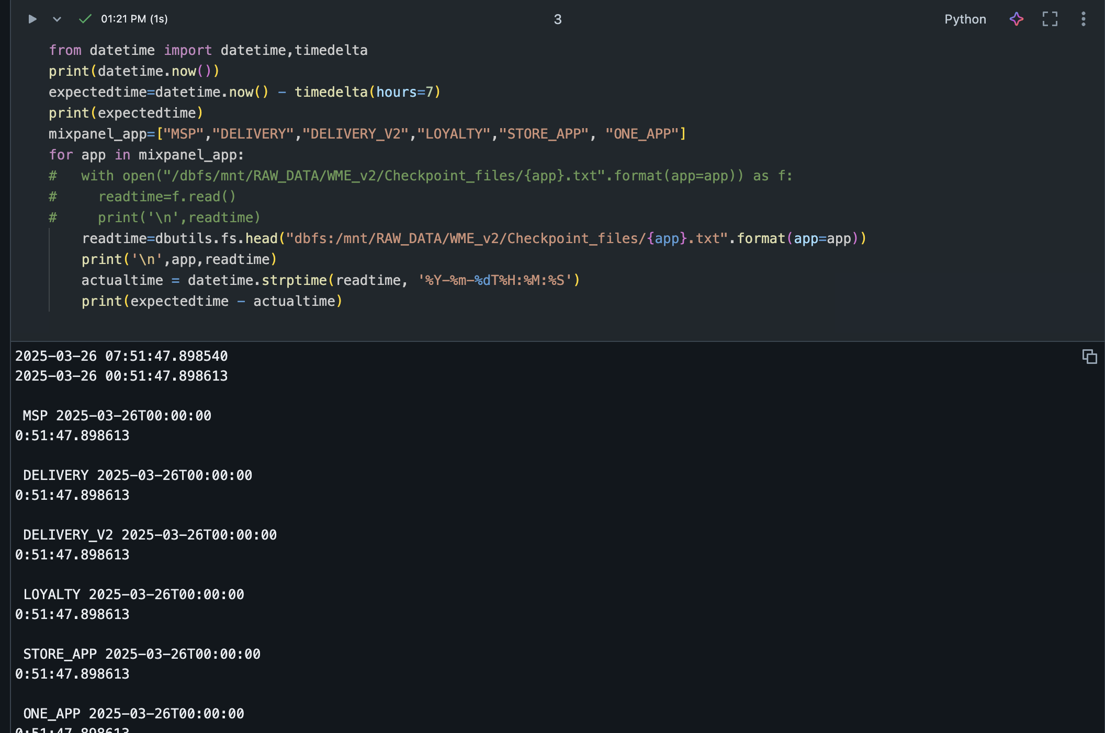

- Run cmd 3 to check the current lag. The lag for all the applications should be less than an hour.

- In order to catch up the lag, login to Mixpanel K8s Dashboard:

https://172.26.96.226/#/workloads?namespace=default

- Go to pods & run the respective Mixpanel pods for lag catchup until the lag is less than an hour

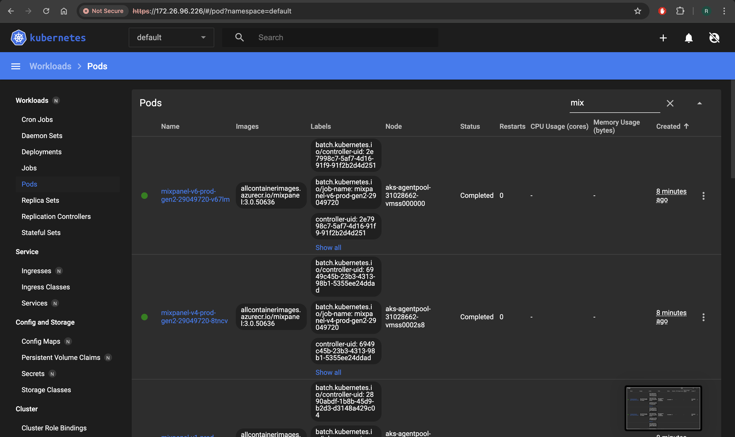

- Finally run the DBKS Notebook cmd 3 to check the lag after running the pods.

